Bon Voyage
Additional Materials
Nicole Maiorano
GAT212-A
Chris Champagne

Images
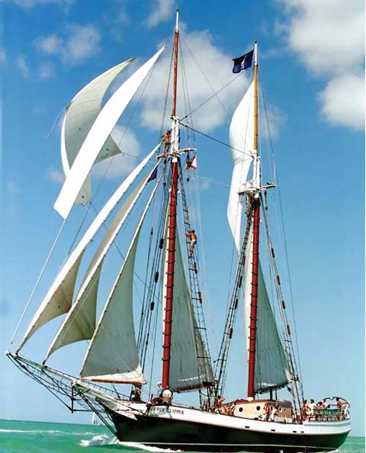
Maiar, the Barefoot South Pacific Cruise Ship
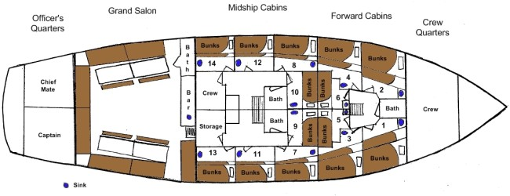
Ship Layout

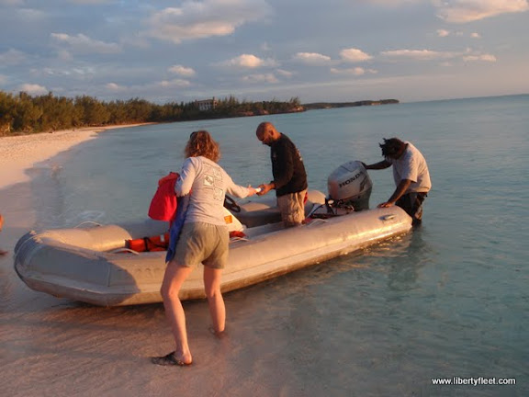
Inflatable Lifeboat
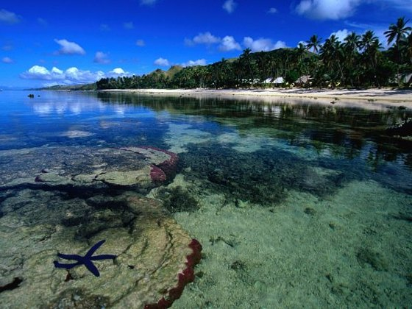
Island Coastline
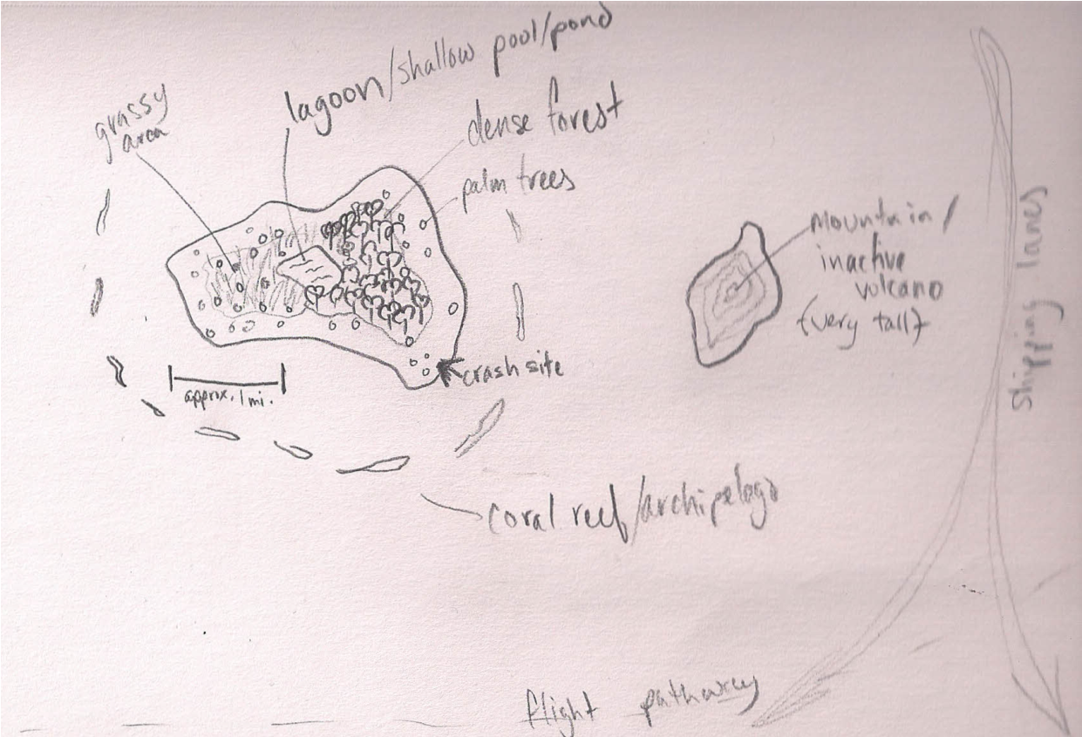
Map of the island

Inventory Cards
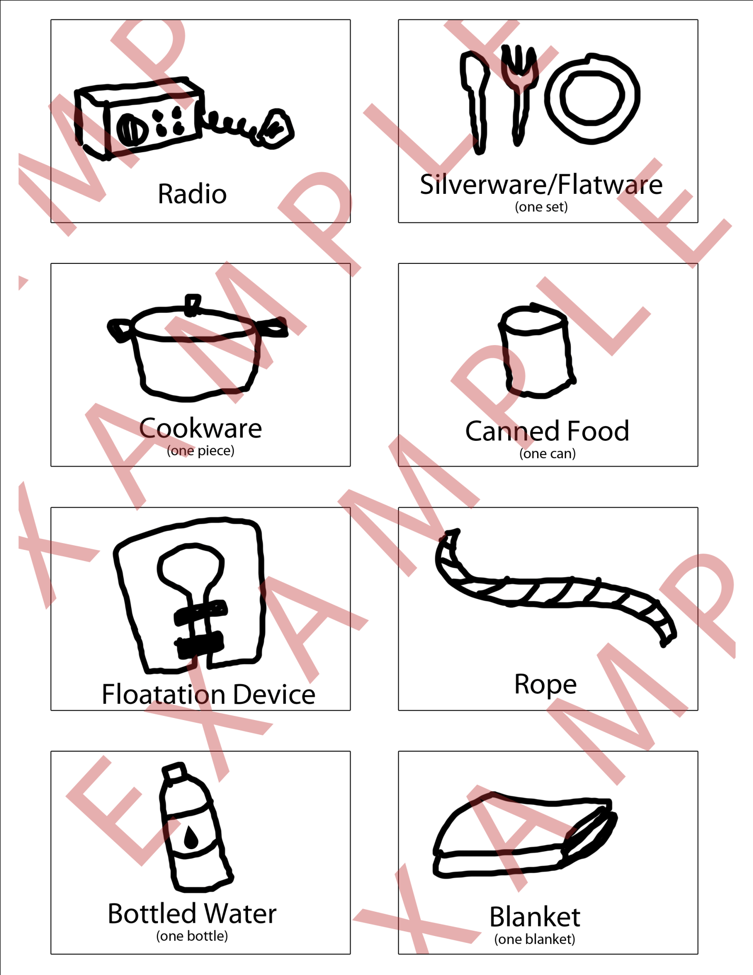
Knowledge Sheet
